**Manual for GamaDex -** July 2013

In case of problems, bugs and other help, pleas contact [r.massarczyk@hzdr.de](mailto:r.massarczyk@hzdr.de) or call me, 0049 (0)351 260 3332

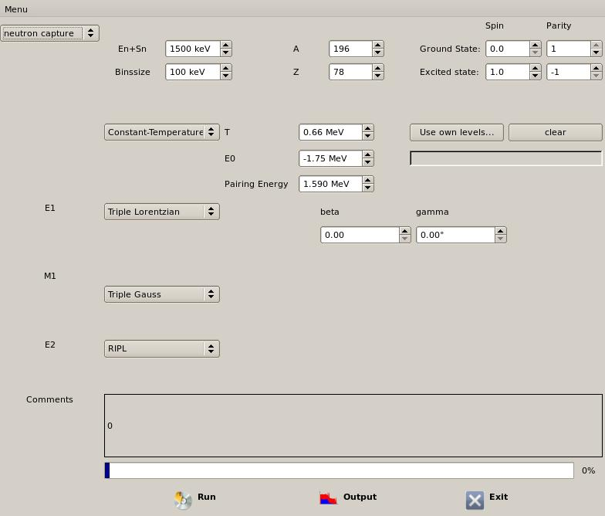

**8**

**7**

**6**

**5**

**4**

**3**

**2**

**1**

**Input parameters:**

1. Change between simulation of (n, γ) and (γ, γ’)
2. En + Sn gives the energy of the excited state in the compound nucleus, can be given in keV-values  
   Binsize is the calculation binning, minimum is 10keV
3. A and Z of the compound nucleus (target + neutron)
4. Spin and Parity of the excited state (start state) and the ground state (final state) in the compound nucleus. If they don’t fit, e.g excited state has half spin and ground state not, the program gives an error comment
5. Decide between CT- or BSFG gas model. The Pairing Energy parameter is defined as in Ref. [1]
6. Here own level schemes can be added to the calculation. If the calculation energy (1) is higher than the highest level given here, the level scheme will be filled by the statistical models given by (5) for input files see separate chapter.
7. The strengths function one can choose between TLO-model ([2]), 2 Lorentz-Parametrization as often found in RIPL ([3]). Also one can use an own strength function. The structure of the input files should be two columns (1st energy in keV, 2nd strength in keV-3) The binning does not have to have the same like the one in (2) the program will adjust it.  
   For M1 one can choose between RIPL-parametrization (see also Ref. [3]) or three-gaussian model (see also [4, 5])  
   E2 is like recommended in RIPL
8. Start, Output and Exit, see separate chapter

**Input level files**

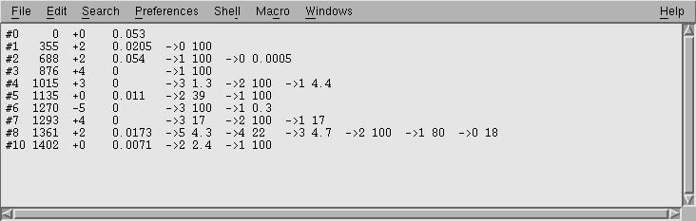

The input files has several columns, as it can be seen in this example for 196Pt.

* The 1st one is just for orientation and should begin with a # sign. Then you can give the number of the level.
* 2nd column is the energy of the level in keV
* 3rd column combines spin and parity, maximum spin difference should be 5 (relative to ground state). Therefore, in the picture above the 9th level is rejected )
* 4th column is the partial radiative neutron capture cross section of the transition to the state as given in the PGAA database (<http://www-nds.iaea.org/pgaa/pgaa7/index.html>). The value is in mb.
* Last columns are a combination of two items. The structure is “🡪x yy” This means a decay to the xth state with a probability of yy. You can give this as absolute values of the branching or as relative values of one intensity, as often found in ENSDF-database.

In the picture above e.g. the 2nd state is a 2+ state at 688keV. In PGAA a transition with E = 7233 keV is observed which goes to this state. The cross section is 0.054. This state decays to the groundstate (probability = 0.0005%) and it also decays to the first excited state (🡪1) with an intensity of 100%.

**Run, Output, Exit**

* By pressing on Run the status bar above the buttons should fill up to 100%
* Exit finishes the program
* By pressing on Output the data is saved. You choose the name for your files, e.g. 196Pt. Then following files are produced then:

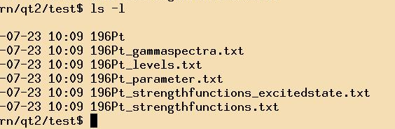

* + **196Pt** is just an information file and a placeholder.
  + **196Pt_gammaspectra** contains the resulting photon spectrum for one capture (1st column energy in keV, second all photons, 3rd only primary gamma rays)
  + **196Pt_levels** has the information about the level scheme. (1st column energy, 2nd spin and parity, 3rd number of levels in the bin, 4th average width, 5th average ground state width, 6th S-Factor, only important for γ,γ’
  + **196Pt_parameter** saves all the input parameters, you can reload to the program by using the point “load parameter” at the “menu”
  + **196_strengthfunctions and 196Pt_strengthfunctions_excitedstate** contain the general strength functions (1st column energy, 2nd E1, 3rd M1, 4th E2). The second file is just for calculations, there are the strength function values replaced by the cross section values given in the Input file. It is only necessary for the decay of the capture state.

1. von Egidy, T. and D. Bucurescu, *Experimental energy-dependent nuclear spin distributions.* Physical Review C, 2009. **80**(5).

2. Junghans, A.R., et al., *Photon data shed new light upon the GDR spreading width in heavy nuclei.* Physics Letters B, 2008. **670**(3): p. 200-204.

3. Capote, R., et al., *RIPL – Reference Input Parameter Library for Calculation of Nuclear Reactions and Nuclear Data Evaluations.* Nuclear Data Sheets, 2009. **110**(12): p. 3107-3214.

4. Schramm, G., et al., *Dipole strength in ^{78}Se below the neutron separation energy from a combined analysis of ^{77}Se(n,γ) and ^{78}Se(γ,γ^{′}) experiments.* Physical Review C, 2012. **85**(1).

5. Massarczyk, R., et al., *Electromagnetic dipole strength up to the neutron separation energy from ^{196}Pt(γ,γ^{′}) and ^{195}Pt(n,γ) reactions.* Physical Review C, 2013. **87**(4).